**Business**  **Week 1 Handout**

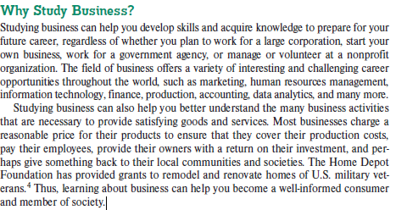

**The definition of Business:**

**Business is the activity of producing, buying, or selling goods or services with the goal of making a profit. It involves the organized effort of individuals or entities to meet the needs and demands of customers, manage resources, and create value through transactions. Businesses can vary in size and structure, from small sole proprietorships to large corporations, but they all aim to generate revenue by providing something of value to consumers.  
  
Now, write it in your own words:**

**________________________________________________________________________________________________________________________________________________________________________________________________________________________________________________________________________________________________________________________________________________________________________________________________________________________________________________________________________________________________________________________________________________________________________________________________________________________________________________________________________________________________**

**Forms of business ownership**

**Sole Proprietorship**

**Definition:** A sole proprietorship is a business owned and run by one person. The owner is responsible for all aspects of the business, including liabilities.

**Advantages:**

1. **Full control:** The owner makes all the decisions.
2. **Simple to set up:** It’s easy and inexpensive to start.
3. **All profits go to the owner.**
4. **Tax benefits:** The business income is reported on the owner’s personal tax return.

**Disadvantages:**

1. **Unlimited liability:** The owner is responsible for all debts and losses.
2. **Harder to raise capital:** Banks may hesitate to give loans.
3. **Limited skills:** The owner handles everything, which can be overwhelming.
4. **No continuity:** The business may dissolve if the owner dies or quits.

**Partnership**

**Definition:** A partnership is a business owned by two or more people who share the profits, losses, and management responsibilities.

**Advantages:**

1. **Shared responsibilities:** Workload and decision-making are split.
2. **More resources:** More owners can bring in additional capital.
3. **Diverse skills:** Each partner brings different expertise.
4. **Easy to set up:** Less complex than corporations.

**Disadvantages:**

1. **Shared liability:** Partners are responsible for business debts.
2. **Profit sharing:** Profits must be split, which can lead to disputes.
3. **Conflicts:** Disagreements between partners can cause problems.
4. **Limited continuity:** The business may dissolve if a partner leaves.

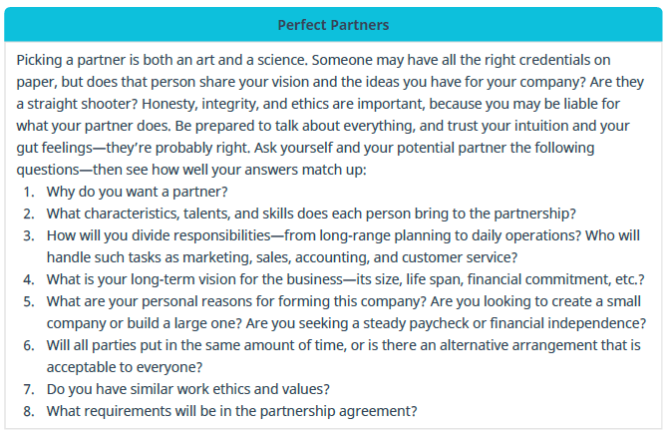

**Corporations**

**Definition:** A corporation is a separate legal entity from its owners, who are called shareholders. It can own property, sue or be sued, and must follow strict regulations.

**Advantages:**

1. **Limited liability:** Owners are not personally responsible for business debts.
2. **Easier to raise capital:** Can issue stocks to attract investors.
3. **Continuity:** The business continues even if ownership changes.
4. **Tax benefits:** Some tax advantages exist for corporations.

**Disadvantages:**

1. **Complex to set up:** More regulations and paperwork.
2. **Expensive to maintain:** Costs for legal and administrative fees.
3. **Double taxation:** The corporation pays taxes, and shareholders also pay taxes on dividends.
4. **Less control:** Shareholders elect a board of directors, so the original owner may have less influence.

**Choose which form of business ownership do you think is best, and give a personalized answer as to why.**  
**_________________________________________________________________________________________________________________________________________________________________________________________________________________________________________________________________________________________________________________________________________________________________________________________________________________________________________________________________________________________________________________________________________________________________________________________________________________________________________________________________________________________________________________________________________________________**

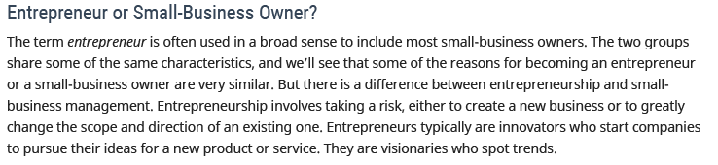

**1. Classic Entrepreneurs**

**Definition:** Classic entrepreneurs are individuals who start their own business from scratch with the aim of growing and expanding it. They typically build a business around their own ideas or innovations.

**Advantages:**

1. **Independence:** They have full control over decisions.
2. **Profit potential:** They can keep all profits once the business is successful.
3. **Flexibility:** They set their own schedules and work methods.

**Disadvantages:**

1. **High risk:** There’s a higher chance of failure, especially in the early stages.
2. **Stress and responsibility:** They bear the full burden of the business's success or failure.
3. **Limited resources:** They often start with limited funds and must do much of the work themselves.

**2. Multipreneurs**

**Definition:** Multipreneurs are entrepreneurs who start and run multiple businesses, often at the same time. They are constantly exploring new opportunities.

**Advantages:**

1. **Diversified income:** They have multiple sources of income from different businesses.
2. **Experience:** Running multiple ventures makes them experienced in handling various business challenges.
3. **Network:** They build extensive connections across industries, opening up more opportunities.

**Disadvantages:**

1. **Time constraints:** Managing several businesses at once can be overwhelming.
2. **Divided focus:** They may struggle to give each business the attention it needs.
3. **Financial risk:** More businesses mean more investment and higher financial risks.

**3. Intrapreneurs**

**Definition:** Intrapreneurs are employees who act like entrepreneurs within a larger company. They innovate and develop new ideas, products, or services for the organization they work for.

**Advantages:**

1. **Lower risk:** They don’t risk their own money, as they work within an established company.
2. **Access to resources:** They have access to the company’s resources like funding, staff, and tools.
3. **Job security:** Even if the project fails, they still have their job and salary.

**Disadvantages:**

1. **Limited control:** They don’t have full autonomy since they operate within the company’s framework.
2. **Profit sharing:** They don’t directly receive the profits generated by their ideas.
3. **Corporate restrictions:** Innovation might be slowed down by company policies or bureaucracy.

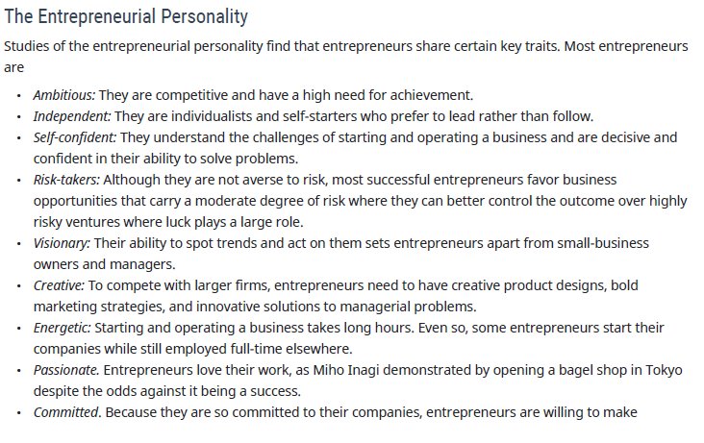

**Choose which form of entrepreneurship do you think is best, and give a personalized answer as to why.**  
**_________________________________________________________________________________________________________________________________________________________________________________________________________________________________________________________________________________________________________________________________________________________________________________________________________________________________________________________________________________________________________________________________________________________________________________________________________________________________________________________________________________________________________________________________________________________**