Business Week 21

**Handout 1: Budget Creation and Understanding Budgeting Basics**

**Objective:**

* Understand the process of creating a business budget and the importance of managing financial resources.

**1. What is a Budget (预算)?**

A **budget** is a plan that helps a business track its **income (收入)** and **expenses (支出)** over a certain period. It’s like a financial roadmap that helps the business plan for the future.

**Why is Budgeting Important?**

* Helps businesses **control spending (控制支出)**.
* Helps plan for future costs and investments.
* Ensures there is enough money for operations.

**2. Key Components of a Budget**

**Income (收入):**  
Money the business makes from selling products or services.  
*Example:* Sales from products.

**Expenses (支出):**  
Money the business spends on running the business (e.g., rent, salaries, supplies).  
*Example:* Rent, employee wages, materials.

**Profit (利润):**  
The money left after expenses are subtracted from income.  
*Formula: Income - Expenses = Profit.*

**3. Creating a Simple Budget (创建预算)**

To create a budget, follow these steps:

1. **Estimate Your Income:**  
   Estimate how much money the business will make in a month or year.
2. **List Your Expenses:**  
   Write down all the things the business needs to spend money on, such as rent, salaries, and marketing.
3. **Calculate Profit:**  
   Subtract your expenses from your income to find out how much profit the business will make.

**Example:**

| **Category** | **Amount ($)** |
| --- | --- |
| **Income** | 10,000 |
| **Expenses** |  |
| - Rent | 2,000 |
| - Salaries | 3,500 |
| - Marketing | 1,000 |
| **Total Expenses** | 6,500 |
| **Profit** | 3,500 |

**4. Activity: Create Your Own Budget**

**Task:**  
In pairs, imagine a small business. Create a budget for one month. List at least 5 sources of income and 5 types of expenses. Calculate the profit based on the given data.

___________________________________________  
___________________________________________  
___________________________________________  
___________________________________________  
___________________________________________  
___________________________________________  
___________________________________________  
___________________________________________  
___________________________________________  
___________________________________________  
___________________________________________  
___________________________________________  
___________________________________________  
___________________________________________  
___________________________________________  
___________________________________________

**Handout 2: Financial Projections and Forecasting**

**Objective:**

* Learn how to forecast a business’s future income, expenses, and profit.

**1. What is Financial Forecasting (财务预测)?**

Financial forecasting is predicting a business’s future financial performance. It helps businesses plan for the future and understand how much money they might make or need.

**Why is Financial Forecasting Important?**

* Helps businesses plan for **growth (增长)** and **investment (投资)**.
* Identifies potential financial problems before they happen.
* Assists in making informed decisions about costs and pricing.

**2. How to Create Financial Projections (财务预测的制作)**

**Step 1:** **Estimate Future Income:**  
Look at past sales or market trends to predict how much the business will make.

**Step 2:** **Estimate Future Expenses:**  
Consider all possible future costs, such as rent increases or additional hiring needs.

**Step 3:** **Create a Cash Flow Projection (现金流预测):**  
Estimate how cash will flow in and out of the business. This helps ensure the business can pay its bills and keep running smoothly.

**3. Types of Financial Projections**

1. **Income Projection (收入预测):**  
   Predicts how much money the business will earn over a period of time.  
   *Example:* Predicting $15,000 in sales for the next quarter.
2. **Expense Projection (费用预测):**  
   Predicts future costs, such as rent, salaries, and utilities.  
   *Example:* Predicting $5,000 in expenses each month for rent and salaries.
3. **Cash Flow Projection (现金流预测):**  
   Shows the inflow and outflow of cash.  
   *Example:* In January, the business expects $10,000 in income and $7,000 in expenses, leading to a cash flow of $3,000.

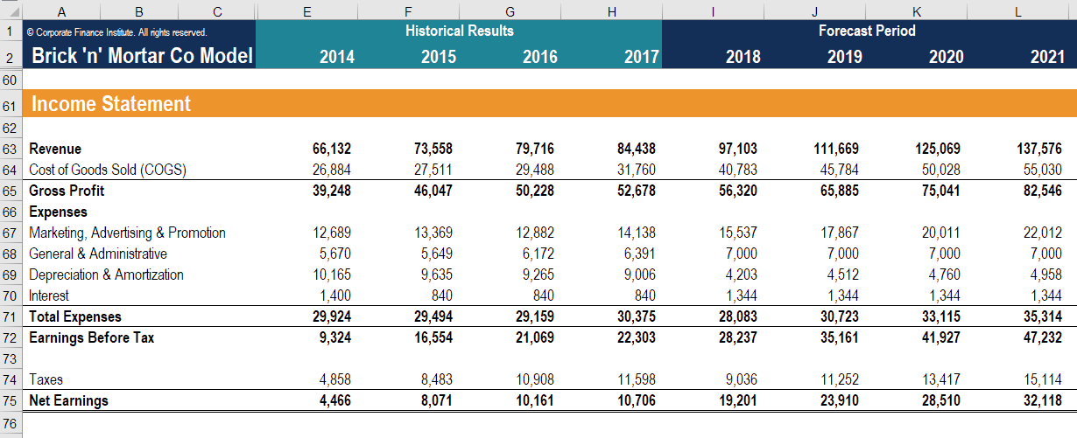

**4. Activity: Create a Basic Financial Projection**

**Task:**  
In small groups, choose a business.

* Estimate income for the next month (e.g., from membership fees).
* Estimate expenses for the next month (e.g., staff salaries, rent).
* Write a simple projection for income, expenses, and cash flow for the next month.

|  |  |  |
| --- | --- | --- |
|  |  |  |
|  |  |  |
|  |  |  |
|  |  |  |
|  |  |  |
|  |  |  |
|  |  |  |

**5. Homework:**

Expand on your financial projection above. Estimate the income and expenses for the first 3 months and provide a cash flow projection.

|  |  |  |  |  |
| --- | --- | --- | --- | --- |
|  |  |  |  |  |
|  |  |  |  |  |
|  |  |  |  |  |
|  |  |  |  |  |
|  |  |  |  |  |
|  |  |  |  |  |
|  |  |  |  |  |

**Summary:**

* **Budgeting** helps businesses manage day-to-day finances.
* **Financial forecasting** helps businesses plan for the future by predicting income, expenses, and cash flow.